
Mathematics Methods Unit 3 2019
Investigation 1: Roller Coaster Design

Name:____________________________ Mark ____ / 28

The mark for this section will constitute 50% of the total investigation mark. Notes will not be allowed in this section, however calculators will be allowed.
Time allowed 40 minutes.

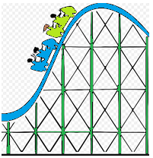
Part C
Answer the questions below in the spaces provided.

Question 1 [ 15 marks]

Your first task is to design an ascent and drop for the first section of roller coaster track.
You will connect two straight stretches of track, and , with part of a parabola , where x and are measured in metres.
The slope of the ascent is 0.74 starting from the origin O and the slope of the drop is
- 1.4.
Determine the equations of the three segments of track indicated below for the given domains, showing all appropriate steps of logic in the space below and on the next page:

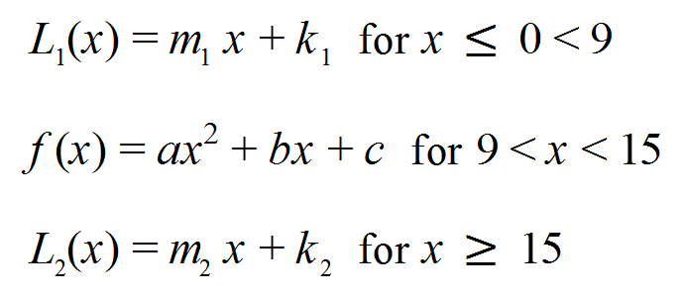

Question 2 [ 8 marks]

Join the same two linear functions in Question 1 with a cubic function this time, given that the top point of the curve between the X-values of 9 and 15 is the point (11,8.2).

Question 3 [ 2,1,1,1 = 5 marks]

a) State two factors that reduce the speed of the roller coaster as it goes down the track?

b) What force keeps the roller coaster on the track as it goes through a loop?

c) Under what circumstances might a negative ordinate (Y-axis) value be possible?

d) Where should the highest point of the track be?

END OF VALIDATION

